Raleway Font Installation

Do not install any “Raleway” Font you find online. Ours is custom made and must be downloaded from our direct file.

- Open the attached ‘Raleway-Regular’ file and click “Save”

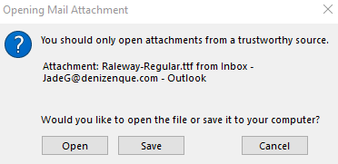

- Click “Save”. Note the location you are saving the file on your PC.

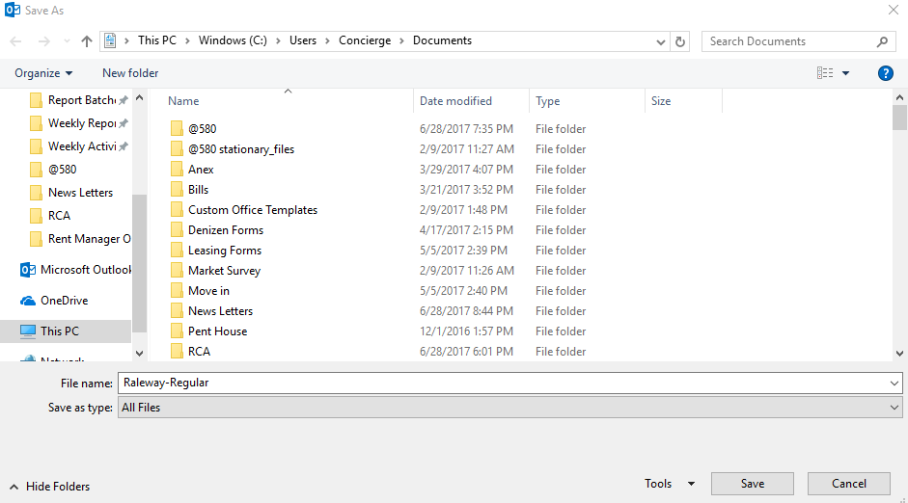

- Locate the File on your PC and Open it.

- Click the “Install” Button.

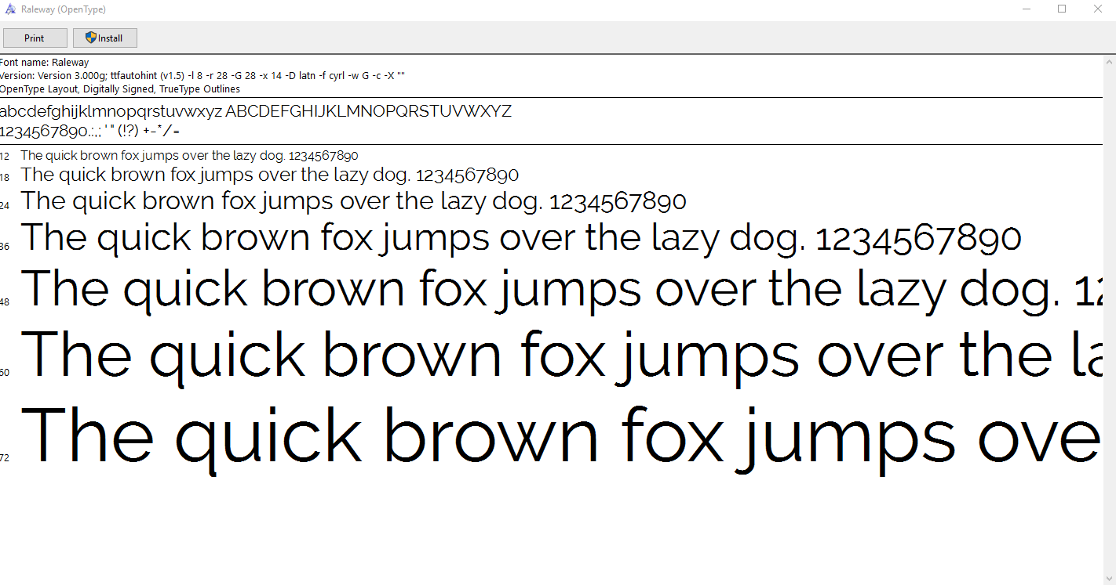

- Open any Microsoft Office Program (Word, Excel, etc.) and type “Raleway” in the font bar to ensure it was installed.

