Hiring Process Policy

The Hiring Process Policy is an Employee QSQ (“Quality Service Quotient”) of Embrace. Hiring new Employees is a regular part of any business. To meet the human resource need it is important to have a seamless process for the timely and successful hiring of new Employees. In addition, the advertising, interviewing, extending an offer of employment, and boarding of a new Employee is an important opportunity to make a great first impression of the organization, its People, and Culture, We Are QUE. Thus, the Hiring Policy was created to meet those goals.

Filling Open Positions

When there is vacancy or the need for a change of, or addition of, staff, the General Manager (or District Manager, aka the hiring manager) completes the Open Position (Form) and forwards via email to the District Manager (aka supervisor) and the Human Resource Administrator for approval. It is imperative that the Open Position (Form) is processed immediately upon the opening of a position as not to delay the process of a new hire.

To complete the Open Position (Form), fully complete all required fields for the location and request, as well as any specific certifications or requirements; sign, date, and send the form via e-mail to your District Manager (Supervisor). The District Manager (Supervisor) will review and approve the Open Position (Form) before submitting it to the Human Resource Administrator.

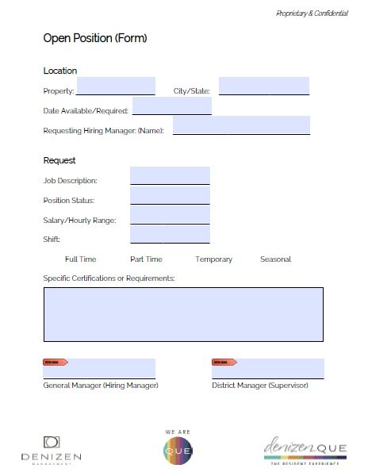
OPEN POSITION (FORM) – can be retrieved on employee login website
The submission of the approved Open Position (Form) will prompt the advertising for the position by the Human Resource Administrator.

Resume Review

Resumes received for the Open Position will be forwarded to the District Manager (Supervisor) for review and selection of prospective candidates. Subsequently, the prospective candidates and their resumes will be sent to the General Manager (Hiring Manager) for review and to schedule interviews.

When scheduling interviews, provide plenty of time to spend with each prospective candidate. It is important to come to the interview prepared. Bring a copy of the resume, the Interview Questions & And What Not To Ask (Form) and the Job Description.

Interviewing Candidates

In consultation with the District Manager (Supervisor), the General Manager (Hiring Manager) will conduct the first interview of the prospective candidates.

Once a perspective candidate arrives for the first interview, they must complete an Employment Application (Form), Background Disclosure (Form), and submit a copy of their State Issued ID prior to the commencement of the interview.

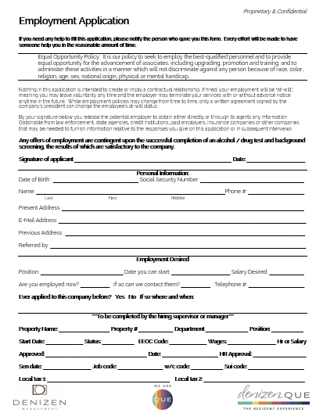
EMPLOYMENT APPLICATION (FORM) – can be retrieved on employee login website
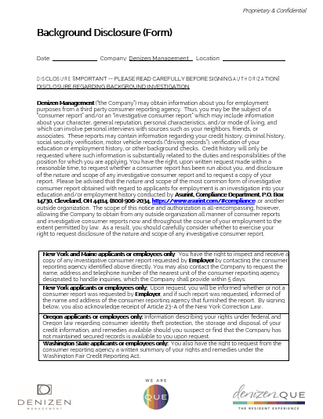
BACKGROUND DISCLOSURE (FORM) – can be retrieved on employee login website

Prospective Service Technician candidates must also complete the Maintenance Skills Assessment (Form) prior to the commencement of the interview.

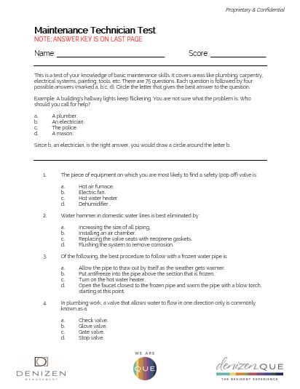
MAINTENANCE SKILLS ASSESSMENT (FORM) – can be retrieved on employee login website

The General Manager (Hiring Manager) is to use the Interview Questions & What Not To Ask (Form), following the instructions including writing down the responses to each question.
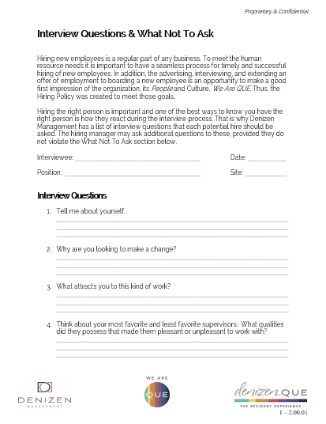
INTERVIEW QUESTIONS & WHAT NOT TO ASK – can be retrieved on employee login website

From those first interviews, the General Manager (Hiring Manager) will send each of the completed Interview Questions & And What Not To Ask (Form), Employee Application (Form) and Maintenance Skills Assessment (Form), if applicable, via e-mail to the District Manager (Supervisor) to discuss the best prospective candidates to be scheduled for a second interview with the District Manager (Supervisor).

Offer for Employment

After the completion of the second round of interviews, the General Manager (Hiring Manager) in consultation with the District Manager (Supervisor), select the best candidate for the position and the selected terms of employment, pay, full or part-time status, and the shift. Then the process of extending an Offer of Employment begins as follows:

- A verbal offer of the position is extended to the candidate and, if accepted, provide the candidate the Drug Test (Form) to be complete it within 48 hours of the verbal offer.

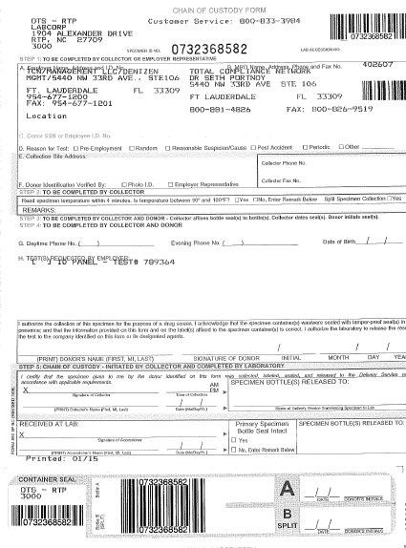
DRUG TEST (Chain of Custody Form) – can be retrieved from designated area properties

- Next a completed New Hire (Form) must be sent via e-mail to the District Manager (Supervisor) for approval. Note that the best shift for the role must be selected (see Nova Time Policy for shift details).

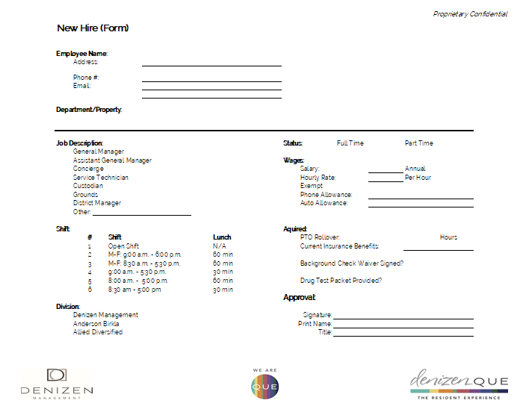
NEW HIRE (FORM) – can be retrieved on employee login website

- The approved New Hire (Form) is sent to the Human Resource Administrator for processing with all documents relating to the candidate;
  - Resume
  - Employee Application (Form)
  - Background Disclosure (Form)
  - Maintenance Skills Assessment (Form)
  - Interview Questions & And What Not To Ask (Form)
- The Human Resource Administrator will prepare an Offer of Employment (Letter) and send it to the candidate.
- The Human Resource Administrator will inform the General Manager (Hiring Manager) and District Manager (Supervisor) if the candidate has accepted the offer and the Background and Drug Test are satisfactory and the candidate is approved to be scheduled to be Boarded.
- Then Managepoint will send the candidate an ehire email to their personal email address. The candidate MUST complete this prior to anything else, as they are not legally an Employee until it is done. For this reason, they will not be issued a NovaTime login until completion

Please Note: No candidate is to be scheduled, or begin work until the Human Resource Administrator has provided approval.

Onboarding a New Employee

The onboarding of New Employees is managed under our QUE 101 Policy, and processed and administered by QUE Training & Development.

